Title or Task: | Graphics & Design Principles Explained
Description: | A look a various elements of design
Files Required | None
Suitable for Classes: | All
Area: | Technology & Enterprise
Teacher: | Mr Peter Faulks
Timeline | Information Sheet with a few questions

Date Due:

Task Brief:
Outcomes: | Students understand the basics of design
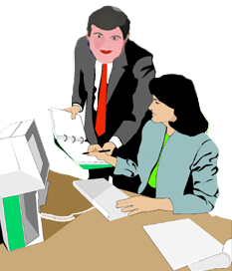

Items highlighted in yellow are tasks for you to complete
Items in Blue are help tips

What is Graphic Design?
Graphic design is the art of visual communication that involves the use of images, words, and ideas to give information to the viewers. Graphic design can be used for advertising, or just for entertainment intended for the mind.

General

The following general hints are provided to help you produce a quality presentation.
- Use simple page design
- Maintain a Point by Point focus
- Stick to familiar conventions
- Stick to the purpose
- Experiment and change your mind if necessary

Principles of Design
Design is the organized arrangement of one or more elements and principles (e.g. line colour or texture) for a purpose.

Awareness of the elements and principles in design is the first step in creating successful visual compositions. These principles, which may overlap, are used in all visual design fields, including graphic design, industrial design, architecture and fine art.

The principles of design are as varied as attitudes regarding modern design. They differ both between the schools of thought that influence design, and between individual practicing designers.

The principles govern the relationships of the elements used and organize the composition as a whole. Successful design incorporates the use of the principles and elements to serve the designer's purpose and visual goals.

There are no rules for their use. The designer's purpose and intent drives the decisions made to achieve appropriate scale and proportion, as well as the degree of harmony between the elements.

Design principles are a technical and artificial method to attempt to produce home architectural and interior design beauty.

The principles of design consist of elements and principles: These may vary depending on the current educational paradigm in place.

Basically design is made up of:- Elements (Physical components like colour line thickness, shape etc. and then put into the context of symetry harmony effects etc.

Samples follow

Design Elements | Design Principles | SPARC(Main Principles)
Colour | Symmetry | Symmetry
Line | Harmony | Proximity
Shape | Dominance | Alignment
Space | Rhythm | Repetition
Typography | Proportion | Colour/Contrast
Texture | Unity
Form | White Space
Value | Contrast
 | Repetition
 | Alignment
 | Proximity
 | Style
 | Balance

Basics of Graphic Design and Color

Colour
Colour is used to emphasis contrasting points or to connect ideas.
Some rules are as follows:-

See also All about colour
- Use contrasting colour combinations for foreground and background. - See colour-wheel info. Or take the colour test on the next page
- Avoid using to many colours on the one screen
- Do not rely on colour as a distinguishing factor.
- Consider the mood or impression a colour conveys
- Keep in mind that some people are colour blind! - Avoid Red-Green or similar combinations.
- Keep in mind cultural differences.
Exercise: Colour Test
- Use the six table cells change different colour backgrounds and different colour fonts

Use this table 4 columns by 3 rows and fill each cell with a different solid colour, then add some text in bold (all the same colour) to each cell and select which looks best. Copy that selection to your answer box 1.

Now select all the fonts in the cells and change the font colour (Answer box 2)

Select the next best combination when you change all the font colours to another colour. (It will probably not be the same cell.) but it should stand out immediately. (Answer 3)

Save this document to your folder include thee colour combinations that really work for you
Note: (A this is a useful chart to help you select some great colour combinations)
COLOUR | COLOUR | COLOUR | COLOUR
COLOUR | COLOUR | COLOUR | COLOUR
COLOUR | COLOUR | COLOUR | COLOUR
COLOUR | COLOUR | COLOUR | COLOUR

Answer 1

Answer 2

Answer 3

Colour Definitions
- Hue is another word for color.
- Chroma is the intensity or purity of color.
- Tint is a color mixed with white.
- Tone is a color mixed with gray.
- Shade is a color mixed with black.
Colour is the most expressive element of art and is seen by the way light reflects off a surface. Colour is used to create illusion of depth, as red colours seem to come forward while blue seems to recede into the distance. Colour, and particularly contrasting colour, is also used to draw the attention to a particular part of the image. On some cases of interior design, colour can be added to increase visual appeal such as the natural colours of wood of a china cabinet. Colour may add visual appeal to a home decor just as colored flowers can add beauty to a field on a prairie.

Color is everywhere and conveys a message even if we don’t realize it. While this message can vary by culture it pays to know what colors “say” in your own corner of the universe, and even what color means to your target market. If you don’t think that color speaks just complete this sentence, “red means ---- and green means –“ even a child will know what red means stop and green means go. If such simple ideas work for all of a given culture or market what could it mean to the graphic design of your website, brochure, or product if you know some of this information. First let’s start with the basics.
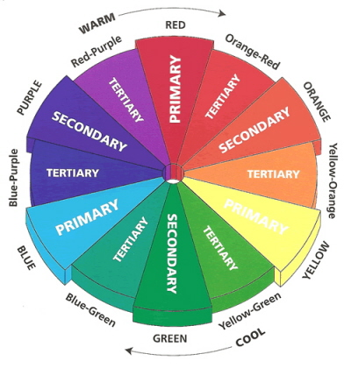

The Color Wheel
We’ve all seen it. The color wheel shows the basic colors, each wheel is different in how many shades of each color is shown, but they are essentially the same.
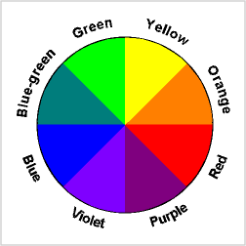

If you spin the colour wheel very fast what colour do you think you would see?

Answer at end of document

Graphic Design and Color Complements
- Analogous colors are adjacent to each other on the color wheel.
- Complementary colors are opposite each other on the color wheel.
Color complements, colors that set each other off, they complement each other. These are colors that are opposite on the color wheel. Such as blue and orange.

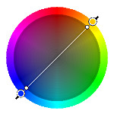
The complementary color scheme consists of two colors that are opposite each other on the color wheel. This scheme looks best when you place a warm color against a cool color, for example, red versus green-blue. This scheme is intrinsically high-contrast.

Graphic Design and Color Depth
Color depth, colors can recede or jump forward. Remember that some colors seem to fall back such as blue, black, dark green, and brown. Other colors will seem to step forward such as white, yellow, red, and orange. This is why if you have a bright orange background it may seem to fight with any text or images that you place on it. The orange will always seem to move forward.

Color Survey: what respondents said colors mean to them.

Happy = Yellow |  | Technology = Silver
Inexpensive = Brown |  | Deity = White
Pure = White |  | Sexiness = Red (tomato)
Powerful = Red (tomato) |  | Bad Luck = Black
Good Luck = green |  | Mourning = Black
Dependable = Blue |  | Favorite color = Blue
Good tasting = Red (tomato) |  | Expensive = Gold
High Quality = Black |  | Least favorite color = Orange
Dignity = Purple |  | Nausea = Green

So in designing your project it’s important to know what colors mean. You can now see why a black back ground with green type would be bad, beyond being nearly impossible to read, if your target market thinks that black represents mourning and green makes them sick. There are exceptions to every rule of course. So you may want to include some research in what colors mean to your target market. Colors that would get the attention of a teen would probably annoy an older person and the colors that appeal to the older person wouldn’t get a second look from a young person. Color may be one of the most overlooked aspects of design.

Contrast

Contrast is the most powerful concept in screen design.

Contrast refers to significant differences between elements. It can capture a user’s attention. It makes text easier to read.  Contrast is often related to colour but can also refer to size, shape, font & position. | 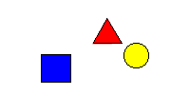Before
Note  How the After diagram demonstrates contrasting size, position and colour. | 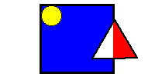After


Lines
Lines can be long or short, straight or curved. Lines can be horizontal, vertical, or diagonal. They create patterns. Lines in graphic design can be solid, dashed, thick, thin, or of variable width.
Sometimes a designer uses a line alone to divide or unite elements on a page. Lines can denote direction of movement (as in diagonal lines and arrows) or provide an anchor to hold elements on a page (such as lines at the top, bottom, or sides of a page). Line is any mark connecting two points.
Many different types of lines appear everywhere. Look around you and you'll see lines that are straight, curved, squiggly, thin, fat, and dotted.
Lines can be used to:
- Organize information.
- Highlight or stress words.
- Connect pieces of information.
- Outline a photo or set it off from other elements.
- Create a grid. (A grid is the underlying structure of a page.)
- Create a chart or graph.
- Create a pattern or rhythm by drawing many lines.
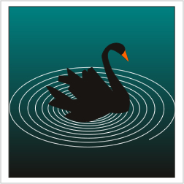
- Direct the reader's eye or create a sense of motion. (Create a sense of action by using a diagonal line.)
- Suggest an emotion

Line is the mark made by a moving point, such as a pencil or brush. The edges of shapes and forms also create lines. It is the basic component of a shape drawn on paper. Lines and curves are the basic building blocks and can also be radial.

Shape
Shape is an area enclosed by lines or curves. It can be geometric or organic. Importantly, a shape automatically creates a negative space around it. Shapes in house decor and interior design can be used to add interest, style, theme to a design like a door. Shape in interior design depends on the function of the object like a kitchen cabinet door. Natural shapes forming patterns on wood or stone may help increase visual appeal in interior design.
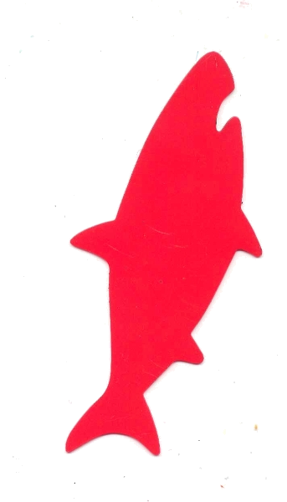
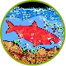

A shape is an enclosed object. Shapes can be created by line, or by color and value changes which define their edges.

Volume and Mass
Shape is considered to be a two-dimensional element, while three-dimensional elements have volume or mass. Therefore, a painting has shapes, while a sculpture has volume and mass.

Positive/Negative shapes
In a picture, the shapes that the artist has placed are considered the positive shapes. The spaces around the shapes are the negative spaces. It is just as important to consider the negative space in a picture as the positive shapes. Sometimes artists create pieces that have no distinction between positive and negative spaces. M. C. Escher was a master at creating drawings where there was no distinction between positive and negative space. Here are two examples of Escher's work which show the interplay between positive and negative space

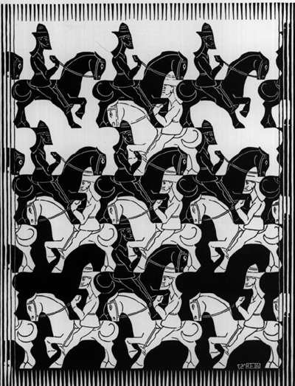 | 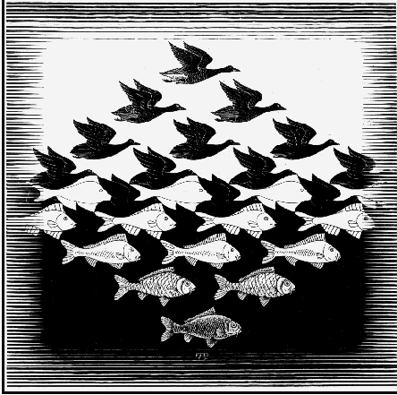
Ans: Shows positive/negative space | Ans: Shows positive/negative space

Negative space, in art, is the space around and between the subject(s) of an image. Negative space may be most evident when the space around a subject, and not the subject itself, forms an interesting or artistically relevant shape,

Positive space, we call the figure or foreground shape positive and the focus of the picture, it is often called the subject matter (usually)
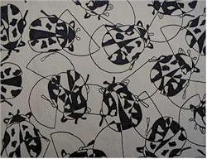

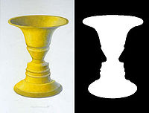
Creating a positive shape element – using a stencil

Typography or Fontography

Text
Serif and Sans-Serif typefaces are used for different purposes. Serif is seen as elegant and sans serif is seen as modern. As well, readability is affected by font type.
Serif and Sans-Serif typefaces are used for different purposes. Serif is seen as elegant and sans serif is seen as modern. As well, readability is affected by font type.
In typography, serifs are non-structural details on the ends of some of the strokes that make up letters and symbols. A font that has serifs is called a serif font (or seriffed font). A font without serifs is called sans-serif, from the French sans="without". Some typography sources refer to sans serif typefaces as "grotesque" (in German "grotesk") or "Gothic", and serif types as "Roman". These terms are no longer commonly used however, except in specific font names.
Ref: http://en.wikipedia.org/wiki/Serif
T
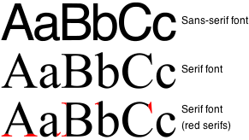
Syntax: The cues that may help the reader follow the order of paragraphs

- E.g. bullets and numbers

Styles
Use the effects and styles of text sparingly. Just enough to "give a taste" without saturation. The following rules apply:
- Make the text large enough to be read, without insulting or stressing the reader.
- Do not use more than two typefaces on a page.
- Do not put to much text on a page. Empty space is as important as text.
- Use all Uppercase sparingly (preferable not at all).
- Three or more attributes (Bold, Italics, Underline, etc) are just too much. One is usually enough.
- Bold fonts are for emphasis and legibility.
- Use shadowed text sparingly - for variety and legibility. Limit its use and keep it consistent.
- Use outlining for legibility.
- Use smoothing for quality appearance.
- Adjust the character spacing. More space makes an "airy" elegant look. Reduced spacing gives a forceful, more modern look.

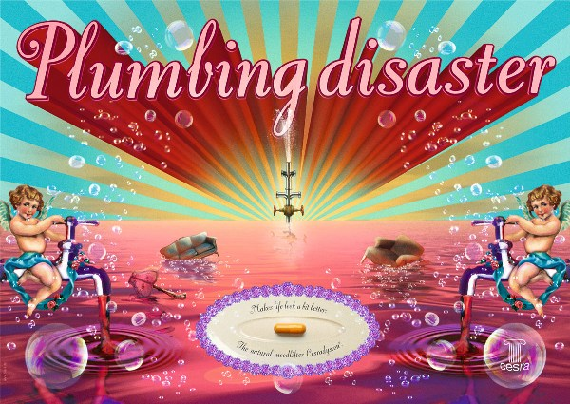

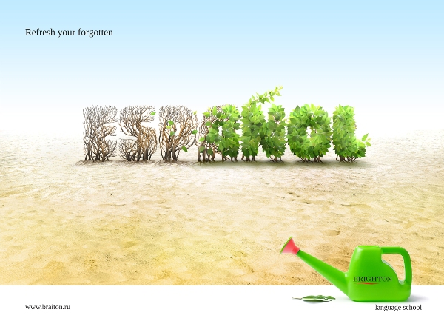

Texture

Texture is the feeling and visual feel of the fabrics, colors, and room accessories. There are two types of texture;

Tactile, = Rough, Smooth, Depth

or

Visual texture, and texture which you can detect with your five senses.
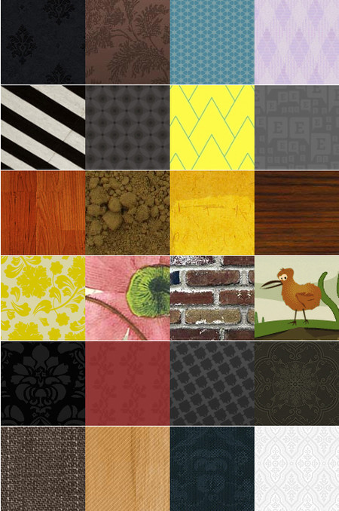

Texture like grass sheets on a wall, or white pebbles embedded in a concrete wall gives a three dimensional look to the wall and a few of shades of its colors. Texture is the roughness of the surface of a material. Surfaces with same or similar textures like fireplace marble tiles and drywall usually look more visually appealing. The quality of finishes of surfaces in home interior design and even on automobiles are important. A smooth and polished surface on a marble tile is also a texture, and smooth quality finishes can enhance the visual appeal of natural material finishes like marble tiles on a wall. Smooth mirror reflective finish on a marble bathroom countertop enhances its looks.

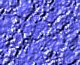

Texture is the surface quality of an object. We experience texture when we touch objects and feel their roughness, smoothness or patterns. Texture is the artist's way of mapping these tactile impressions on to the two-dimensional picture. Texture is created by varying the pattern of light and dark areas on an object. Notice how the areas of light and dark give the impression of depth to the image below

Balance
- There are three different types of balance when using color, shape, and position:
  - Symmetry
  - Asymmetry
  - Radial symmetry

- Balance is the act of comparing or estimating two things, one against the other, and the contrast between:
  - Empty space (white space) and filled space
  - Text and images
  - Color and no colors and different colors
  - Textures against flat colors

Designs in balance have the parts of the design arranged in a planned, coherent visual pattern. "Balance" is a concept based on human perception and the complex nature of the human senses of weight and proportion. Humans can evaluate these visual elements in a wide range of situations to determine a sense of balance. A design composition does not have to be symmetrical or linear to be considered balanced. It is also true that perfectly symmetrical and linear compositions are not necessarily balanced.

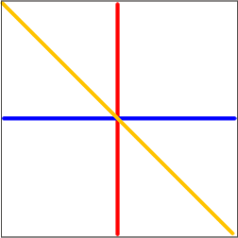 | 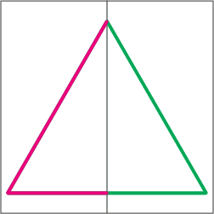
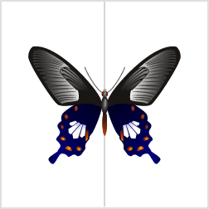 | Symmetrical Balance

- You can usually identify at least one of three lines of symmetry.
  - Horizontal
  - Vertical
  - Diagonal

Asymmetrical or radial distributions of text and graphic elements can achieve balance in a composition. Asymmetry means without symmetry -- with no mirror imagery. It is possible to achieve balance without symmetry.

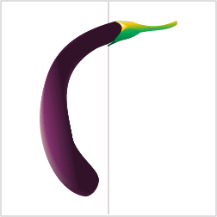 | 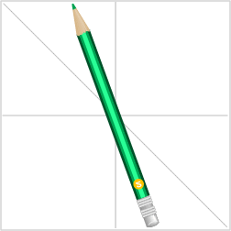
Asymmetrical, or informal, balance is usually much more interesting than symmetrical balance. In asymmetrical balance the imaginary central pivot point is still presumed to be present; however, instead of mirror images on each side of the picture area, the subject elements are notably different in size, shape, weight, tone, and placement. Balance is established by equalizing the element forces in spite of their differences. | Asymmetrical Balance
 | 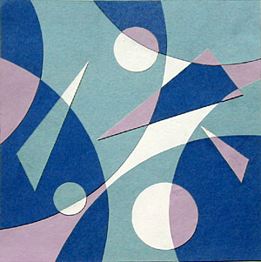  Jamie Dykstra - Asymmetry –  Collage - 9 in. by 9 in.  Notice that the asymmetrical images have less unity but more variety.
  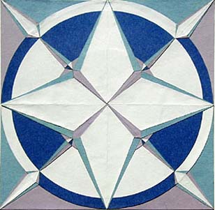
  Jamie Dykstra - Symmetry –
  Collage - 9 in. by 9 in.
  This is an example of biaxial symmetry -- mirrored left and right with almost the same imagery mirrored top and bottom with some color changes.

Radial Balance
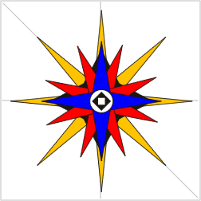 | 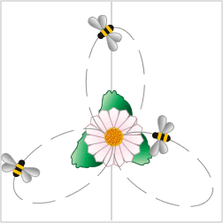

Form

Form may be created by the forming of two or more shapes. It may be enhanced by tone, texture and colour. Form is considered three-dimensional showing height, width and depth. It can be illustrated or constructed.

http://www.usask.ca/education/coursework/skaalid/theory/cgdt/balance.htm

The Design Principles

Dominance (Emphasis)

Dominance of an object can be increased by making the object larger, more sophisticated, more ornate, by placing it in the foreground, or standout visually more than other objects in a project. The primary focus point or area receives the largest emphasis in a room. Emphasis hierarchy avoids style confusion.

Dominance, Focal Point or area in a room's decor

Areas of interest. Guides the eye into through and out of the image through the use of sequence of various levels of focal points, primary focal point, secondary, tertiary, etc.

Emphasis hierarchy may give direction and organization to a design, and avoid subconscious confusion to sometimes improve the design's (like a house) visual appeal and style. Emphasis hierarchy or focus is not giving each object (like a bed or curtain) in a project (like a bedroom decor) equal dominance.

Emphasis

Making a specific element stand out or draw attention to the eye. Emphasis can be achieved in graphic design by placing elements on the page in positions where the eye is naturally drawn, by using other principles such as contrast, repetition, or movement. Bold and italic type provides emphasis for text. Graphic elements gain emphasis through size, visual weight, color, complexity, uniqueness, placement on the page, and other features.

Rhythm

Successful designs have an effective ebb and flow. Text and graphics should seem to be paced and patterned. Spacing is an effective application of this principle. Second, human beings are more comfortable with variation in general. Psychologically, most any serious lack in variation of anything (a solid, a line, a sound, a situation) can become very boring. Adding a little variation at non-specific intervals (every now and again) gives most any design an interesting appeal as long as it is not overdone.
In setting type, rhythm can be created or disrupted. Compare the gibberish strings, "as erav mono ewone zenao oro remuna oravanam" and "githol urtym reislyt quadirit". Notice how the latter seems to be more organic and readable than the former. This is resultant of two things. One, the eye more easily follows abnormalities and variation, like an ocular foothold. Too-narrow columns result in over-hyphenation. Images that interrupt a passage of text can break the rhythm for the reader and they could disturb the visual appearance of the page.

Proportion

This indicates the relative visual size and weight of particular graphical elements in a design composition.

Unity
- Unity: The correct balance of composition or color that produces a harmonious effect.
- What is the focus of the message?

Unity creates a feeling of wholeness. Unity is usually achieved when the parts complement each other in a way where they have something in common. Unity can be achieved through the use of the same color, or tints of the same color, or using a similar graphic style for illustrations. Unity refers to a sense that everything in the artwork belongs there, and makes a whole piece. It is achieved by the use of balance and repetition. Two objects like a living room and a dining room can be unified by giving these similar features like a shared hardwood floor design.



White Space
White space is extravagance. White space is the surface of the paper on which you are printing showing through and on which you are choosing NOT to print. If economy and conservation were your chief concern, then white space would be at minimum; obviously you would use it all up. So white space is used for purely semiotic values; for values of presentation which transcend economic values by insisting that the image of what you present is more important than the paper you could be saving. It is likely that this aesthetic is more extravagant with paper than any other graphic design value – especially in Japan. Printing plates, separations, paper and four or more colour presses still have to be used and paid for with the inclusion of white space. White space is a negative cost right down the production line – except for giving style.
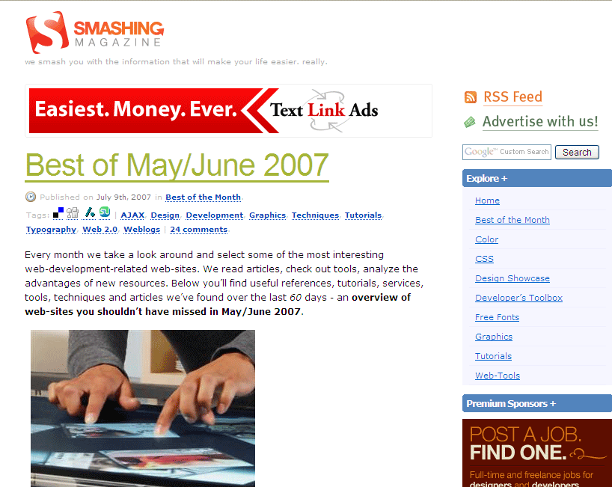

Good Example of White Space use

Areas of a design devoid of text or graphics. White space includes margins, gutters, space between lines of type (leading), off-set of text from images (text wraps) and any other part of the page that is empty. White space is also analogous to "negative space" where "positive space" is defined as images, blocks of text, and other graphical elements. In graphic design, the white space, or negative space, is considered an important element of the overall design. It is used - and evaluated - based on the same criteria as the rest of the elements in the design. White space can add to or detract from the balance, unity, harmony, rhythm, and overall success of a design. White space can provide emphasis, contrast, and movement. It can be used for repetition and pattern, and work within various relationships with other elements of the positive and negative spaces in the design.
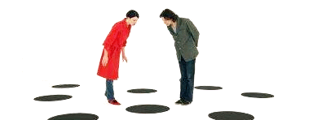

Contrast
Contrast is the occurrence of contrasting elements, such as colour, value, size, etc. It creates interest and pulls the attention toward the focal point.

Distinguishing by comparing/creating differences. Some ways of creating contrast among elements in the design include using contrasting colors, sizes, shapes, locations, or relationships. For text, contrast is achieved by mixing serif and sans serif on the page, by using very different type styles, or by using type in surprising or unusual ways. Another way to describe contrast, is to say "a small object next to a large object will look smaller". As contrast in size diminishes, monotony is approached.

Repetition

The recurrence of elements within a piece: colours, lines, shapes, values, etc. Any element that occurs is generally echoed, often with some variation to keep interest.
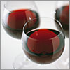

Repeating a sequence; having it occur more than a few times. In design, repetition creates visual consistency in page designs, such as using the same style of headlines, the same style of initial capitals, or repeating the same basic layout from one page to another.
Excessive repetition (monotony) may lead to boredom and uninteresting compositions. If one cannot avoid excessive repetitions for any reason, do not forget to add some visual breaks and white spaces where eyes can rest for a while.
Repetition (Rhythm, Pattern)

Alignment

Alignment refers to the position of how elements “line up” relative to each other.

Alignment helps to balance the picture elements on a screen. By placing an item out of alignment on purpose makes it stand out.

Vertical and horizontal alignment should be considered.

Left-aligned text is the easiest to read.

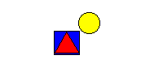

Proximity
Proximity refers to the placement and position of media elements for effect.
With careful placement, elements can take on additional meaning .
Text positioned in small chunks is easier to read.
Careful positioning also improves the “balance” of the page. This is more pleasing to the eye. Proximity
Closeness or distance of individual design elements. Close proximity indicates a connection.


Proximity in home decor is the placing of similar objects closer together physically, and unlike objects (decor) further apart. Helps to produce harmony by grouping like objects. For example, different furniture styles with different colors compressed in a small bedroom does not look as nice as the same furniture placed further apart in a very large living room.

Proximity refers to the placement and position of media elements.
With careful placement, elements can take on additional meaning .
Text positioned in small chunks is easier to read.
Careful positioning also improves the “balance” of the page. This is more pleasing to the eye.

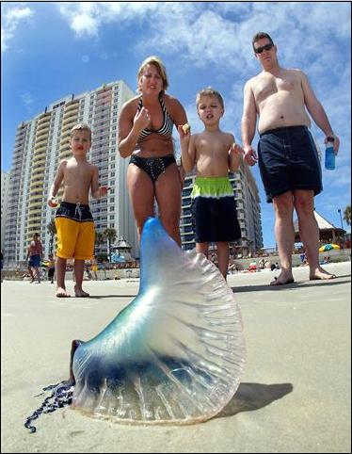 | 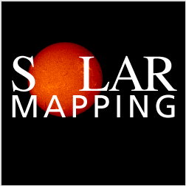
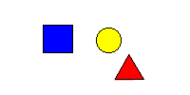 | 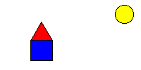  Related items placed together

Style
Use the effects and styles of text sparingly. Just enough to "give a taste" without saturation. The following rules apply:
- Use all Uppercase sparingly (preferable not at all).
- Three or more attributes (Bold, Italics, Underline, etc) are just too much. One is usually enough.
- Bold fonts are for emphasis and legibility.
- Use shadowed text sparingly - for variety and legibility. Limit its use and keep it consistent.
- Use outlining for legibility.
- Use smoothing for quality appearance.
- Adjust the character spacing. More space makes an "airy" elegant look. Reduced spacing gives a forceful, more modern look.

Symmetry

Symmetry: Arranging different elements evenly on the page.

Harmony

As with music, graphical elements can be said to be working in harmony - the individual parts come together as visually compelling and a meaningful whole. Disharmony can also be used just as it is in musical compositions: to enhance the emotional complexity, to challenge the viewer, and to provide a contrast within the overall composition. Harmony is achieved through the sensitive balance of variety and unity. Color harmony may be achieved using complementary or analogous colors. Harmony in design is similarity of components or objects looking like these belong together. Harmony is when some or many the components (usually three objects depending on size of project or room) such as furniture in a room share a common trait or two. A common trait could be: color(s), shape(s), texture, pattern(s), material, theme, style, size, or functionality. For example a drapery could share the same color that is on a pillow or wallpaper. This is called color coordination in wall paper design. Harmony and unity generally make designs more visually appealing and interesting. Is a technical and artificial process for attempting to produce interior design beauty? Design harmony may be used to avoid design or furniture chaos in most cases.

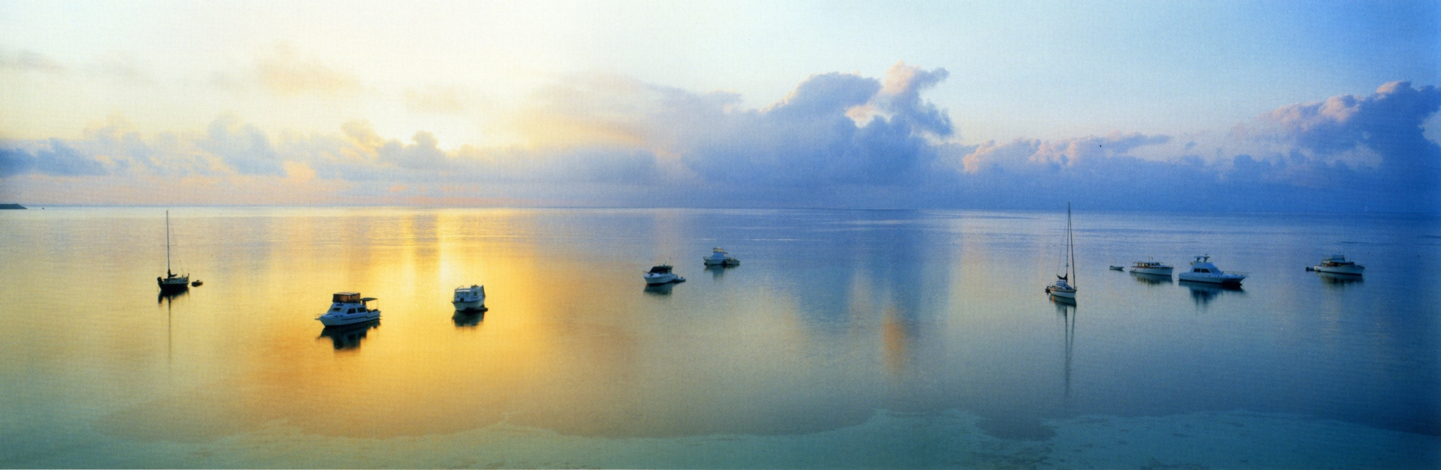

Graphic Design and Color Harmony
Color harmony, colors that go together well. These will be colors that are next door to each other on the color wheel. Such as blue and green. In reference to clothes these colors match each other. Instinctively most of us know which colors go together when we dress ourselves every morning.
Visual balance comes from arranging elements on the page so that no one section is heavier than the other. Or, a designer may intentionally throw elements out of balance to create tension or a certain mood.

Backgrounds

- Backgrounds provide the tone of the presentation. - funny, serious, elegant etc.
- Determine the impression and then select the background that suits.
- Plain colours for informative presentations.
- Atmosphere is created using specially selected backgrounds.
- Choose appropriate colours, patterns and pictures for special backgrounds.

Other Elements of Design

Gestalt

Sometimes considered a distinct principle of design, gestalt is the concept that "the whole is greater than the sum of its parts." Gestalt is a concept from psychology, where theorists note that humans have a propensity to conceptually group things together to make a meaningful whole. When viewing designs, humans apply this principle unconsciously by seeing connections and relationships among and between the elements in the design. The overall perception of gestalt in a design is created through harmony, unity, balance, proportion, proximity, and other visual cues. Designers can use this principle to create visual connections and relationships that clarify and strengthen the overall "feel" and meaning of the design.

Movement

Movement is creating an instability, making motion to blur the image. Movement can be achieved by using graphic elements that direct the eye in a certain direction such as arrows that point the way overtly or a series of lines or dots that get progressively larger or smaller, creating a more subtle sense of movement. Movement can be accomplished simply by using a photograph or clip art of something moving - a runner - as opposed to something stationary - a person standing.

Value
Value is how light or darkened the color you are using. Value is also referred to as tone.

Balance
Can be either symmetrical or asymmetrical depending on if the right or left side is identical or not.
Also refers to a sense that dominant focal points are balanced and don't give a feeling of being pulled too much to any part of the artwork. Balance can be balance by location of objects such as windows on a house, balance by volume or sizes of objects, balance by color (like desired brightness in a room).
Rhythm in interior design also may be used to reduce randomness. For example, placing four plant pots in a row and evenly spaced apart on a floor produces an organized look.

Variety (Alternation)
The use of dissimilar elements, which creates interest. Variety like a painting or some reflective wood panels added on a plain wall may be used to reduce monotony. Helps infuse color to a house decor to attempt to increase design beauty.

Proportion (Scale)
Proportion involves the relationship of size between objects. Proportion is also relative sizes of surface areas of different colors in a room. The proportion of color areas such as on a wall of a living room may be chosen to be visually pleasing. Proportion also depends on functionality of object. For example, for the best proportion between a room and furniture, the sizes of furniture depends on the size of the room.

Functionality
A design must have good functionality. For example a bedroom must function well as a place to sleep and store clothing as well as looking nice.

Attraction
Attraction is how much an observer is attracted to a particular design such as a particular style of a house. May involve studying the psychology why certain people are attracted more to particular designs than other designs.

Artistic Unity
Artistic unity is staying on the story (like a science fiction novel) topic or story line, telling only one story at a time, staying on the style of a home in interior design. Avoids distraction or subconscious confusion in house decor style. Helps strengthen the style of a house, gives a clear design style communication.

Genuineness in Media and Form
Genuineness in media and form in architecture and home interior design is using real material for finishes rather than faux. The beauty of natural patterns of stone or wood, and real crystallized metals may be used to enhance the visual appeal of an interior design. Using real metal, glass or crystal instead of plastic simulations. Real style, prestige, glamour or luxury rather than pretense. For example, an arborite kitchen counter top cannot duplicate the mirror reflectivity and natural beauty of granite counters for long. In some cases, furniture made of real wood could look nicer than faux wood (photographic wood).

Color Theory
Color theory in interior design includes the color wheel. The color wheel are the colors of the rainbow arranged in a circular array. Color theory also involves the idea of how color affects human thought and emotions. Colors that have red such as orange, reddish-brown and yellow are assumed to be warm colors because we associate these with sunlight. Colors than have blue are cool colors because we associate blue will cool water and ice. Color harmony is a pleasing combinations of colors and the amount of these colors in a design like a room decor. Color harmony is also using a limited number of colors in a color palette usually seven or less initially to help preserve design unity.

http://www.goshen.edu/art/ed/Compose.htm#elements
Styles
Wipes
A wipe brings presentations to life - and also kills them! The following rules should apply.
- Avoid using more than 1 wipe per screen.
- Give the viewer time to absorb the information. Also, do not make it laboriously slow.
- Use a focus colour to emphasize successive items.
- Observe the conventions of motion. Left to right etc.
Graphics
Images can make a significant impact on your presentation. Apply these rules to your graphics:
- The graphic must relate to the message.
- Photographic quality is important. Make sure the images are clear and sharp. If necessary, enhance then using appropriate tools.
- Avoid placing text over the top of images. The text is often hard to read and the image obscured.
- Make sure the graphics are not cluttered.
Sound and Animation
Sound and animation is the essence of multimedia and is used to grab the attention of the viewer.
- Keep the sound and images in sync. If sound and vision appear together, they should happen at the same time.
- Musical selections should star and finish in appropriate places to provide continuity.
Video
- Clips should be short in their duration. No more than 20 seconds in general.
- Maintain the original capture size when presenting video. Enlarging a small video image actually makes it look far worse than in the small format as the resolution is very poor.
Answers
White very fast or light grey not so fast

References
http://www.usask.ca/education/coursework/skaalid/theory/cgdt/shape.htm
http://desktoppub.about.com/cs/designelements/a/linesintro.htm
http://daphne.palomar.edu/design/bsymm.html
http://www.usask.ca/education/coursework/skaalid/theory/cgdt/balance.htm
http://www.color-wheel-pro.com/color-theory-basics.html
http://www.adigitaldreamer.com/articles/graphic-design-principles.htm
http://en.wikibooks.org/wiki/Graphic_Design/Principles_of_Design"
http://en.wikipedia.org/wiki/Design_principles_and_elements#Elements_of_Design

